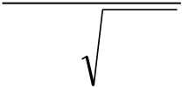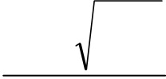

**Operational Modelling of High Temperature Electrolysis (HTE)**

Patrick Lovera a, Franck Blein b, Julien Vulliet b,

*a Commissariat à l'Energie Atomique, Direction de l'Énergie Nucléaire, Département de Physico - Chimie, Centre de Saclay, F-91191 Gif sur Yvette, Cedex ; e-mail: patrick.lovera@cea.fr*   
*b Commissariat à l'Energie Atomique, Direction des Affaires militaires, Département Matériaux, Centre du Ripault, BP 16, F-37260 Monts; e-mails: franck.blein@cea.fr,julien.vulliet@cea.fr*

***ABSTRACT:***

Solid Oxide Fuel Cells (SOFC) and High Temperature Electrolysis (HTE) work on two opposite processes.

The basic equations (Nernst equation, corrected by a term of over-voltage) are thus very similar, only a few signs are different. An operational model, based on measurable quantities, was finalized for HTE process, and adapted to SOFCs. The model is analytical, which requires some complementary assumptions (proportionality of over-tensions to the current density, linearization of the logarithmic term in Nernst equation). It allows determining hydrogen production by HTE using a limited number of parameters.

At a given temperature, only one macroscopic parameter, related to over-voltages, is needed for adjusting the model to the experimental results (SOFC), in a wide range of hydrogen flow-rates. For a given cell, this parameter follows an Arrhenius law with a satisfactory precision.

The prevision in HTE process is compared to the available experimental results.

***KEYWORDS:***Operational modeling, SOFC, HTE.

Hydrogen consumption in a Solid Oxide Fuel Cell (SOFC) and hydrogen production by High Temperature Electrolysis (HTE) are two opposite processes:

- SOFC: formation of water steam from hydrogen and oxygen, according to reaction (R1); the reaction is exothermic and spontaneous, it produces electrical and thermal energy. The irreversibilities decrease the available voltage at the boundaries of the cell

- HTE: formation of hydrogen and oxygen from water, according to reaction (R2); the reaction is conversely endothermic and non spontaneous. Thus, it is necessary to supply electrical and thermal energy. The irreversibilities increase the electrical energy to be supplied to the electrolyzer.

The behaviour of both reactors (electrolysis cell or fuel cell) is mainly based on Nernst equation, which correlates the Gibbs free energy ΔG and the electromotive force of a chemical system.

Applied to both reactions Nernst equation reads:

|  |  |
| --- | --- |
| SOFC:  (R1): H2gas + ½ O2 gas H2Ovap , | HTE:  (R2): H2Ovap H2gas + ½ O2 gas |
| |  |  |  |  |  |  |  |  |  |  |  | | --- | --- | --- | --- | --- | --- | --- | --- | --- | --- | --- | | E(R1) | = | E°(R1) | − | R | T | Ln | ⎛⎜  ⎜ | P H 2 O | | ⎞ ⎟  ⎟ | |  |  |  |  | 2 | F |  | ⎜⎝ | P H 2 | P O 2 | ⎟ ⎠ |   (1) | |  |  |  |  |  |  |  |  |  |  |  | | --- | --- | --- | --- | --- | --- | --- | --- | --- | --- | --- | | E(R2) | = | E°(R2) | − | R | T | Ln | ⎛⎜  ⎜ | P H 2 | P O 2 | ⎞ ⎟  ⎟ | |  |  |  |  | 2 | F |  | ⎜⎝ | P H 2 O | | ⎟ ⎠ |   (2) |

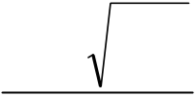

:

where E is the electromotive force (in V), E° the standard electromotive force (in V) and P the pressure

|  |  |  |  |  |  |  |  |  |  |  |  |  |
| --- | --- | --- | --- | --- | --- | --- | --- | --- | --- | --- | --- | --- |
| (in bar). E is correlated to the Gibbs free energy ΔG of reaction (R1) by | | | | | | | E(R1) | = | − | ΔG(R1) | | . Similarly, |
|  |  |  | 2 | F |  |
|  | °(R1) | = | − | ΔG°(R1) | | . |
|  |  |  |  | 2 | F |  |  |  |  |  |  |  |

As reaction (R1) is spontaneous, ΔG(R1) < 0 and E(R1) >0.

Considering that E(R2) = - E(R1), one can observe that both equations (1) and (2) can be written on a

unique manner, provided that the orientation of the intensities in the main circuit are taken opposite.

|  |  |  |  |  |  |  |  |  |  |  |  |
| --- | --- | --- | --- | --- | --- | --- | --- | --- | --- | --- | --- |
| E | = | E° | + | R | T | Ln | ⎛⎜ | P H 2 | P O 2 | ⎞ ⎟ | (3) |
|  |  |  |  | 2 | F |  | ⎜⎜⎝ | P H 2 O | | ⎟ ⎟ ⎠ |  |

where E° is taken positive in all cases. E° only depends on temperature.

However, Nernst equation is valid when no current crosses the electrolyte, i.e. no hydrogen is

produced (HTE) or consumed (SOFC). As soon as a current circulates in the electrolyte, some

irreversibilities occur. 3 types of over-voltages can be pointed out:

- Ohmic over-voltage, due to the passage of current in resistive materials (anode, electrolyte, cathode)

- Activation over-voltage, due to the formation of activated complexes during partial semi-reactions at

the electrodes, described by Volmer - Butler equation

- Concentration over-voltage, due to the fact that the real concentrations to be used in Nernst equation

are concentrations at the interface electrode - electrolyte, and the measured concentrations are

bulk concentrations.

The last type of over-voltage is a mathematical artefact, the first two ones are real over-voltages,

producing a local waste power by Joule effect.

We aim to develop an operational model, i.e. a model only based on macroscopic quantities.

**A complementary notation:**

On the hydrogen side, it may be noticed that one mole of hydrogen replaces (or is replaced by) exactly

one mole of water. Hence, the pressure is constant along the course of the gases. We introduce ξ,

which is the transformation rate of H2 into H2O (or opposite), and we get:

- in the case of HTE : P H 2 = P°ξ and P H 2 O = P°1(−ξ)

- in the case of SOFC: P H 2 = P°1(−ξ) and P H 2 O = P°ξ

where P° is the initial pressure P°= P H init

2 + P H init

2 O

ξin and out are respectively the transformation rates at the inlet and at the outlet of the cell.

**Experimental conditions**

The characteristics of the cell are:

- Electrolyte thickness: 140 µm Electrolyte material: zirconia doped with yttrium oxide (3% w/w)

- Anode thickness: 40 µm Anode material: gadolinium-doped ceria

- Cathode thickness: 60 µm Cathode material: strontium-doped lanthanum manganate

- Active area: 70 or 98,5 cm²

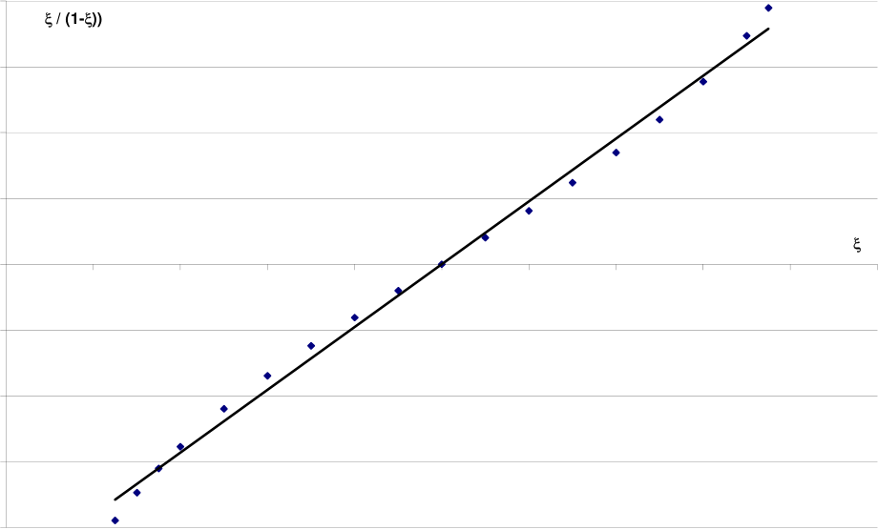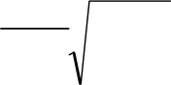

The cell is supplied with 300 ml.min-1 of N2 (anodic side) and 2,6 l.min-1 of air (cathodic side). The heating ramp is 30°C.h-1. The anode is reduced at 700 °C, by the progressive introduction of H2. Then the cell is heated to the operating temperature under H2.

The shape of the device used in experiments is a disc; the inlet of the gas is supposed to be punctual at the centre of the disc; the outlet is at the external edge of the cell.

The inlet gas is water steam in HTE (or a mixture H2O - H2), pure hydrogen (or a mixture H2O - H2) in a SOFC. As the reactions (R1) or (R2) proceed on the whole surface of the cell, the transformation rate

|  |  |  |  |
| --- | --- | --- | --- |
| is a function of location, i.e. | ξ = | ξ(r) | , where r is the distance from the centre of the cell to the current |

point.

**SOFC model**   
In order to get an analytical model, some simplifications were carried out: - Over-voltages are proportional to the current

|  |  |  |  |  |  |
| --- | --- | --- | --- | --- | --- |
| density. The proportionality factor is called | | | **2** | **Ln (**ξ **/ (1-**ξ**))** | ξ |
| Area Surface Resistance (ASR). It is noted Rs | | | **1.5** |
| (in Ω.m-2) | | |
| - Oxygen pressure | P O 2 | is supposed to be | **1** |
| constant throughout the cell | | | **0.5** |

**0**

|  |  |  |  |  |  |  |  |  |  |  |  |  |  |  |  |  |  |  |  |  |  |  |  |  |
| --- | --- | --- | --- | --- | --- | --- | --- | --- | --- | --- | --- | --- | --- | --- | --- | --- | --- | --- | --- | --- | --- | --- | --- | --- |
| - The logarithmic term in Nernst equation is | | | | | | | | | | | **0** | **0.1** | **0.2** | **0.3** | **0.4** | **0.5** | **0.6** | **0.7** | **0.8** |  | **0.9** | |  | **1** |
| replaced by a linear approximation, valid | | | | | | | | | | | **-0.5** | | | | | | | | |
| between ~0.125 and ~0.875 (Figure 1). We can | | | | | | | | | | | **-1** | | | | | | | | |
| write | Ln | ⎛⎜ |  | |  |  | | --- | --- | | ξ | ⎞ |   ⎟ | ≈ | −A | + | B | ξ | with A ≈ 2.385 and | **-1.5** | | | | | | | | |
|  | ⎝ | 1 | − ⎠ |  |  |  |  |  | **-2** | | | | | | | | | Ln | ⎛⎜ |  | ξ | ⎞⎟ |
| B ≈ 4.770. This approximation allows an | | | | | | | | | | | Figure 1: linear approximation of the function | | | | | | | | |
| analytic resolution of Nernst equation. | | | | | | | | | | |
|  | ⎝ | 1 | −ξ | ⎠ |

The shape of the device used in experiments is a disc; the inlet of the gas is supposed to be punctual at the centre of the disc; the outlet is at the external edge of the cell. The electrolyte material is zirconia doped with yttrium oxide (3% w/w), the anode material … the cathode material…   
The inlet gas is water steam in HTE (or a mixture H2O - H2), pure hydrogen (or a mixture H2O - H2) in a SOFC. As the reactions (R1) or (R2) proceed on the whole surface of the cell, the transformation rate ξ is a function of location, i.e.ξ =ξ(r)   
, where r is the distance from the centre of the cell to the current point.

|  |  |  |  |  |  |  |  |  |  |
| --- | --- | --- | --- | --- | --- | --- | --- | --- | --- |
| The mass balance in a little crown leads to | j | = | q   u | | F | ∂ | ξ(r) | | , where j is the current density, q is the |
| ∂ |  |
|  |  |  | *π* | r |  |  | ∂ | r | u |

useful molar flow-rate (H2 + H2O), in mol.s-1, and F the Faraday's constant (≈ 96500 C.mol-1). The final differential equation describing the behaviour of a cell reads:

|  |  |  |  |  |  |  |  |  |  |  |  |  |  |  |  |  |  |  |  |
| --- | --- | --- | --- | --- | --- | --- | --- | --- | --- | --- | --- | --- | --- | --- | --- | --- | --- | --- | --- |
| E | = |  |  | + | R | T | Ln | ⎛⎜ | 1 | − | ξ | P |  | ⎞ ⎟ | − | ∑ | (irrevers | bilities) | (4) |
|  |  |  | 0 |  | 2 | F |  | ⎜⎝ |  | ξ |  | O | 2 | ⎟ ⎠ |  |  |  |  |  |

The first 2 terms on the right side of the equation describe the reversible tension (Nernst equation), the last one describe the irreversibilities (which decrease the available voltage at the cell).

With the simplifications described previously and writing the total resistance Rs × j, the equation becomes:

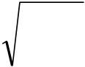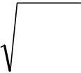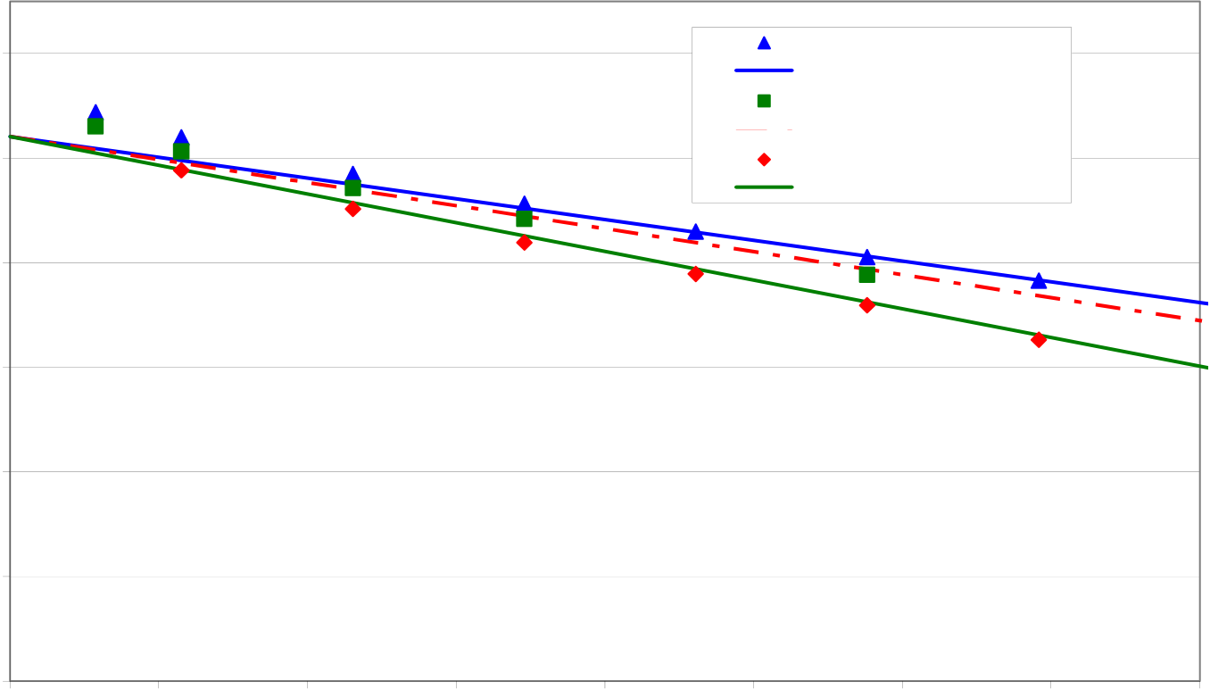

|  |  |  |  |  |  |  |  |  |  |  |  |  |  |  |  |  |  |  |  |  |  |  |  |  |  |  |  |  |  |  |
| --- | --- | --- | --- | --- | --- | --- | --- | --- | --- | --- | --- | --- | --- | --- | --- | --- | --- | --- | --- | --- | --- | --- | --- | --- | --- | --- | --- | --- | --- | --- |
| E | ≈ | E |  | + | R | T | ( + | A | − | B | ξ | ) | + | R | T | Ln | ⎛ ⎜ | P | ⎞⎟ | − | R |  | q | u | | F | ∂ | ξ(r) | | (5) |
|  |  |
|  |  |  | 0 |  | 2 | F |  |  |  |  |  |  |  | 2 | F |  | ⎝ | O 2 | ⎠ |  |  | s | π | | r |  |  | ∂ | r |  |

and it can be easily integrated.

In a SOFC process, the operational equations are:

|  |  |  |  |  |  |  |  |  |  |  |  |  |  |  |  |  |  |  |  |  |  |  |  |  |  |  |  |  |  |  |  |  |  |  |  |  |  |
| --- | --- | --- | --- | --- | --- | --- | --- | --- | --- | --- | --- | --- | --- | --- | --- | --- | --- | --- | --- | --- | --- | --- | --- | --- | --- | --- | --- | --- | --- | --- | --- | --- | --- | --- | --- | --- | --- |
| Voltage at the edge of the cell: E = E° - R* I | | | | | | | | | | | | | | | | | | | | | | |  |  |  |  |  |  |  |  |  | in | |  | B | | (6) |
| Intensity: |  |  |  |  |  | (ξ | out | | | | − | ξ | in | ) | | | | | | | | |
| I | = | 2 | q   u | F | ⎛ ⎜ | P |  | ⎞⎟ | + | A | - | B | ξ | ⎫⎪ | (7) |
| Voltage at zero intensity: | | | | | | | | | E° | | = | E | 0 | + | | R | | T | | ⎧ ⎪⎨Ln  ⎪⎩ | | | (8) |
| 2 | | F | | ⎜ ⎝ | O | 2 | ⎟⎠ |  |  |  |  |  | ⎬⎪⎭ |  |
| Equivalent resistance: | | | | | | R | | * | | = | R | ° | 1 | |  | e | − | | 1 | | |  | with | | | R = | | | R | | | T | (9) |
| R | | ° |
|  | Σ |  |  | 4 | | q u | | F | 2 |  |
| - | R | | | s |  |  |  |  |  |

**Validation of the equations (SOFC) at a given temperature:**

The results are gathered in the next figure (Fig. 2). The voltage (in mV) obtained at the boundaries of the cell is plotted versus the intensity (in A) crossing the cell.

3 experiments are presented. Only one parameter is adjusted (the ASR, Rs in the previous equations - all other parameters are known). As expected, the model fits correctly the linear part of the curves. In particular, the model correctly represents the variation of the global cell resistance as a function of the useful flow-rate.

Some discrepancies are obtained at low intensity; they can be overcome by a best fit of the logarithmic expression (see Fig. 1 for instance).

|  |  |  |
| --- | --- | --- |
| **Voltage at the boundaries of the cell (mV)** | **1200** | **600 mL/min - experimental** |
| **600 mL/min - model** |
| **350 mL/min - experimental** |
| **1000** |
| **350 mL/min - model** |
| **180 mL/min - experimental** |
| **800** | **180 mL/min - model** |
| **600** |
| **400** |
| **200** |

**0**

|  |  |  |  |  |  |  |  |  |
| --- | --- | --- | --- | --- | --- | --- | --- | --- |
| **0** | **0.05** | **0.1** | **0.15** | **0.2** | **0.25** | **0.3** | **0.35** | **0.4** |

**Current density (A.cm-2)**

Figure 2: Validation of the operational equations on SOFC experiments at a given temperature (900°C) for various hydrogen flow-rates

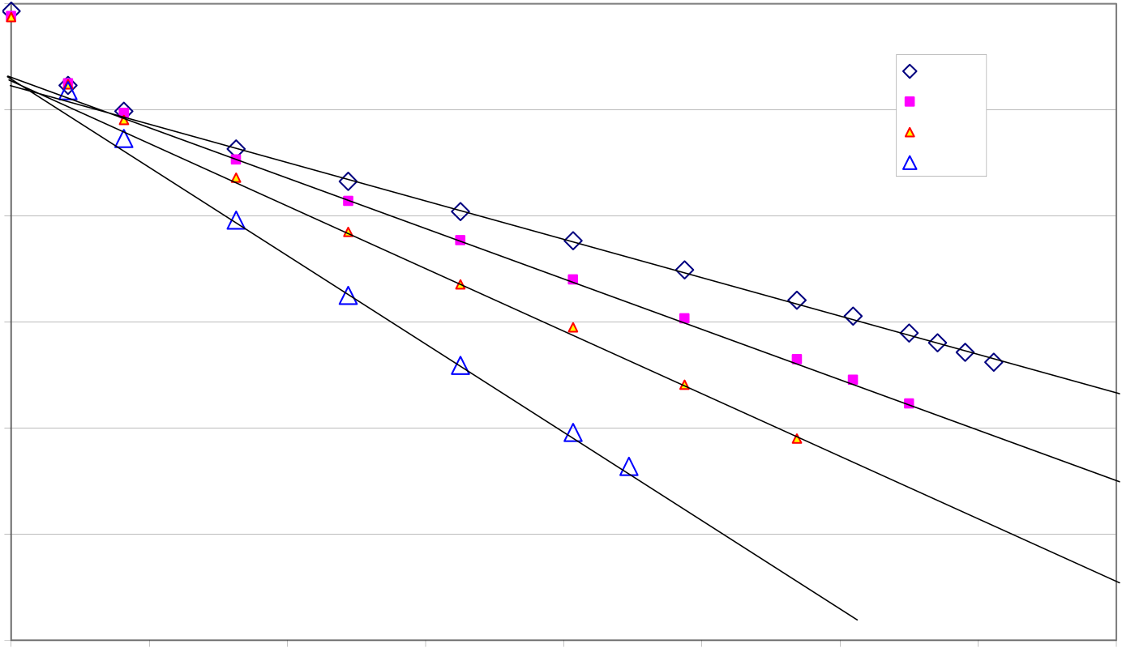

**Validation of the equations (SOFC) at a various temperatures:**   
Some experiments were carried out at different temperatures, with a same hydrogen flow-rate. Each experiment allows to fit a value of Rs(T)

**1200**

|  |  |  |
| --- | --- | --- |
| **Voltage at the boundaries of the cell (mV)** | **1000** | **900°C** |
| **850°C** |
| **800** | **800°C** |
| **750°C** |
| **600** |
| **400** |
| **200** |

**0**

|  |  |  |  |  |  |  |  |  |
| --- | --- | --- | --- | --- | --- | --- | --- | --- |
| **0** | **0.05** | **0.1** | **0.15** | **0.2** | **0.25** | **0.3** | **0.35** | **0.4** |

**Current density (A.cm-2)**   
Figure 3: Validation of the operational equations on SOFC experiments at a given hydrogen flow-rate for various temperatures   
An Arrhenius law can be fitted to the experimental results. For the tested cell, one obtains

|  |  |  |  |  |  |  |  |
| --- | --- | --- | --- | --- | --- | --- | --- |
| Rs(T) | ≈ | 7.262 | 10 | −8 | e | 8538 | , Rs in Ω.m2 and T in K. |
| T |

The previous expression depends on the tested cell. Rs can be split into 3 terms, as noticed previously:   
- an Ohmic contribution, which can be estimated, knowing the materials (thickness and conductivity versus temperature)   
- an activation contribution, which could be estimated provided that the parameters of Butler - Volmer equation (i.e. exchange current density) are known,   
- a concentration contribution, which could be estimated provided that diffusion coefficients in the various materials are known (a diffusion process is expected in the porous anode and cathode).

Some complementary experiments are needed for a better estimation of the two last contributions.

**HTE model**   
The equations describing HTE process are the same as those previously integrated, excepted for 2 minor details:

|  |  |  |  |  |  |  |  |  |  |  |  |  |  |
| --- | --- | --- | --- | --- | --- | --- | --- | --- | --- | --- | --- | --- | --- |
| - the logarithmic term is | Ln | ⎛⎜ | 1 | - | ξ | ⎞⎟ | instead of | Ln | ⎛⎜ |  | ξ | ⎞⎟ | , hence the approximation is (A - B ξ) instead |
|  |  | ⎝ |  | ξ |  | ⎠ |  |  | ⎝ | 1 | −ξ | ⎠ |  |

of (- A + B ξ)   
- the irreversibilities increase the needed HTE voltage, instead of decreasing the available SOFC voltage (it is a direct consequence of the second Principle of Thermodynamics).

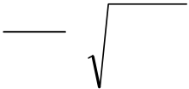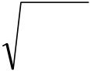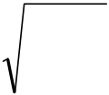

The fundamental equation becomes:

|  |  |  |  |  |  |  |  |  |  |  |  |  |  |  |  |  |  |  |
| --- | --- | --- | --- | --- | --- | --- | --- | --- | --- | --- | --- | --- | --- | --- | --- | --- | --- | --- |
| E | = | E |  | + | R | T | Ln | ⎛⎜ |  | ξ |  | P |  | ⎞ ⎟ | + | ∑ | (irreversi bilities) | (10) |
|  |  |  | 0 |  | 2 | F |  | ⎜⎝ | 1 | - | ξ | O | 2 | ⎟ ⎠ |  |  |  |  |

which can be simplified to:

|  |  |  |  |  |  |  |  |  |  |  |  |  |  |  |  |  |  |  |  |  |  |  |  |  |  |  |  |  |  |  |  |
| --- | --- | --- | --- | --- | --- | --- | --- | --- | --- | --- | --- | --- | --- | --- | --- | --- | --- | --- | --- | --- | --- | --- | --- | --- | --- | --- | --- | --- | --- | --- | --- |
| E | ≈ | E |  | + | R | T | (− | A | + | B | ξ | ) | + | R | T | Ln | ⎛ ⎜ | P |  | ⎞⎟ | + | R |  | q | u |  | F | ∂ | ξ(r) | | (11) |
| ∂ |  |
|  |  |  | 0 |  | 2 | F |  |  |  |  |  |  |  | 2 | F |  | ⎝ | O | 2 | ⎠ |  |  | s | π | | r |  |  | ∂ | r |  |

and integrated to:

|  |  |  |  |  |  |  |  |  |  |  |  |  |  |  |  |  |  |  |  |  |  |  |  |  |  |  |  |  |  |  |  |  |  |  |
| --- | --- | --- | --- | --- | --- | --- | --- | --- | --- | --- | --- | --- | --- | --- | --- | --- | --- | --- | --- | --- | --- | --- | --- | --- | --- | --- | --- | --- | --- | --- | --- | --- | --- | --- |
| Voltage at the edge of the cell: E = E° + R* I | | | | | | | | | | | | | | | | | | | | |  |  |  |  | − |  |  | B | ξ | in | | ⎫ ⎪⎬  ⎪⎭ | | (12) |
| Intensity: |  |  |  |  |  | (ξ | out | | | − | | ξ | in | ) | | | | | | |
| I | = | 2 | q   u | F | ⎛⎜ | P |  | ⎞⎟ | A | + | (13) |
| Voltage at zero intensity: : | | | | | | | | | E° | | | = | E | 0 | + | | R | T | ⎧ ⎪⎨Ln  ⎪⎩ | | (14) |
| 2 | F | ⎜⎝ | O | 2 | ⎟⎠ |  |  |  |
| Equivalent resistance: | | | | | | R | | * | = | | R | ° | 1 | | - | e |  | 1 | |  | with | | | | R = | | R | | T | B | | | (15) |
| R | ° |
|  | − | Σ |  | 4 | q u | | F | | 2 |  |
|  |  | R | | s |  |  |  |  |

Equations (13) and (15) are exactly identical to equations (7) and (9), equation (14) differs from equation (8) by the signs before A and B.

**Validation of the equations (HTE)**

The electric supplying is connected and the electrochemical behaviour of the cell is studied under different flow-rates or working potential. In fact this working potential determines the mode at which the electrolysis cell operates. There are 3 means of operating high temperature electrolysis: endothermic, thermoneutral and exothermic operation:   
- At the cell voltage of 1.3 V (corresponding to the ∆H/2F of the reaction of water dissociation), the electrolysis generate enough heat to compensate endothermic losses. The process is thermoneutral. - Above 1.3 V, excess heat is available to heat the steam at the electrolysis module inlet up to the operating temperature in a heat exchanger.

- Below the thermoneutral voltage, a high temperature high temperature heat is needed. This can lead to an increase in the overall efficiency, but also to an increase of the investment costs for the process.

The model, described by equations (13) to (15) was applied to HTE experiments, using a "zero parameter approach" (i.e. the value of Rs given by equation (9) was used without any correction). The results are plotted in the Figure 4 (experiments at 900°C for various initial compositions of the inlet gas) and Figure 5 (experiments at 800 and 900°C, for 2 flow-rates).

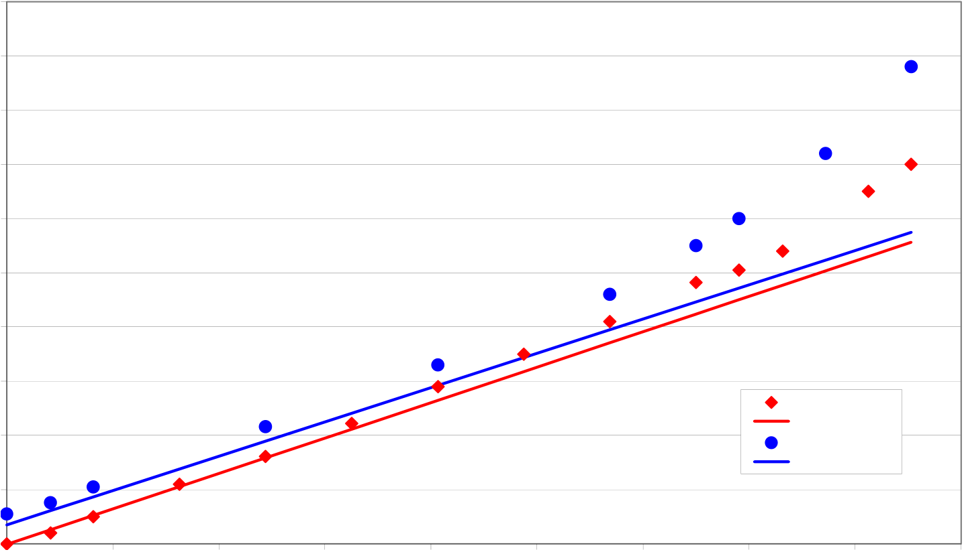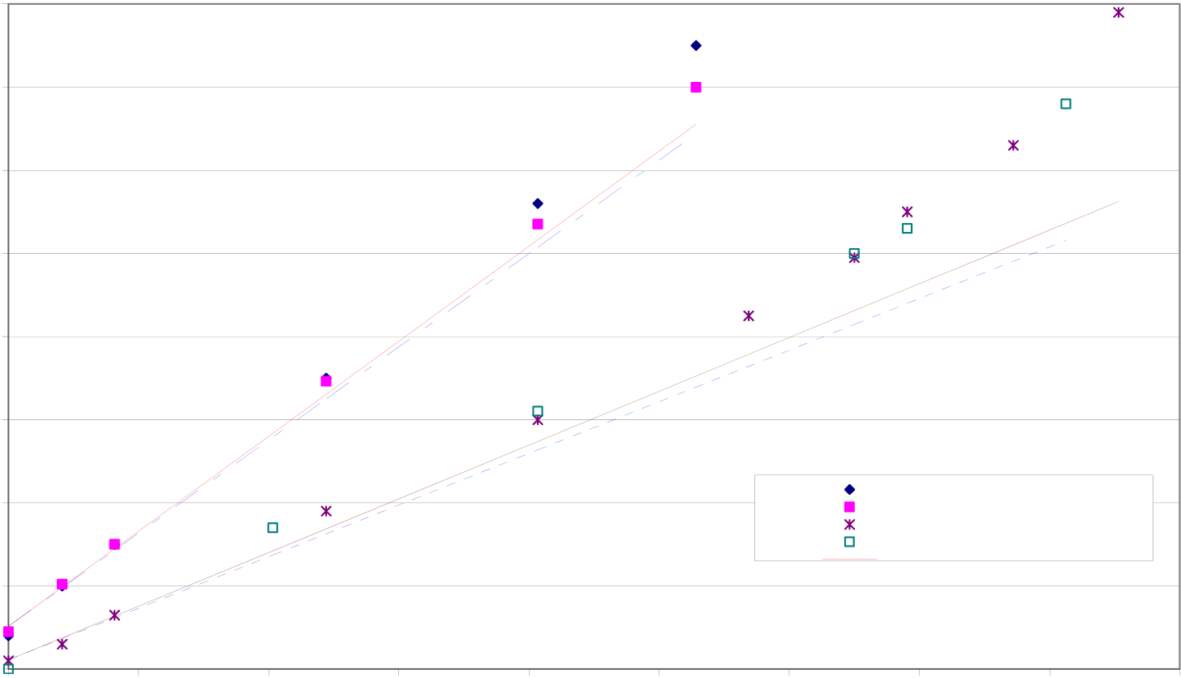

**1800**

|  |  |  |
| --- | --- | --- |
| **Voltage at the boundaries of the cell (mV)** | **1700** | **5 % H2** |
| **1600** |
| **1500** |
| **1400** |
| **1300** |
| **1200** |
| **1100** |
| **1000** | **Model 5 %** |
| **20 % H2** |
| **900** | **Model 20 %** |

**800**

|  |  |  |  |  |  |  |  |  |  |
| --- | --- | --- | --- | --- | --- | --- | --- | --- | --- |
| **0** | **0.05** | **0.1** | **0.15** | **0.2** | **0.25** | **0.3** | **0.35** | **0.4** | **0.45** |

**Current density (A.cm-2)**

Figure 4: Validation of the operational model on HTE experiments at a given gas flow-rate for various initial compositions (H2O - H2) at 900°C. H2O flow-rate is 16 g.h-1.

**1600**

**1500**

|  |  |  |
| --- | --- | --- |
| **Voltage at the boundaries of the cell (mV)** | **1400** | **800°C - 16 g/h**  **800°C - 20 g/h**  **900°C - 16 g/h**  **900°C - 20 g/h**  **Modèle 16 g/h - 800°C** |
| **1300** |
| **1200** |
| **1100** |
| **1000** |

**900**

**800**

|  |  |  |  |  |  |  |  |  |  |
| --- | --- | --- | --- | --- | --- | --- | --- | --- | --- |
| **0** | **0.05** | **0.1** | **0.15** | **0.2** | **0.25** | **0.3** | **0.35** | **0.4** | **0.45** |

**Current density (A.cm-2)**

Figure 5: Validation of the operational model on HTE experiments at various temperatures for two different gas flow-rates. H2O - H2 ratio is 90-10 %.

The fit is rather good, although no correction was performed. The main difference between SOFC and HTE is the deviation to linearity, which occurs for lower intensities in HTE than in SOFC.

This difference could be due to concentration over-voltage, as hydrogen and water steam have not the same diffusion coefficient through the electrode material. However, complementary experiments have to be carried out in specific conditions.

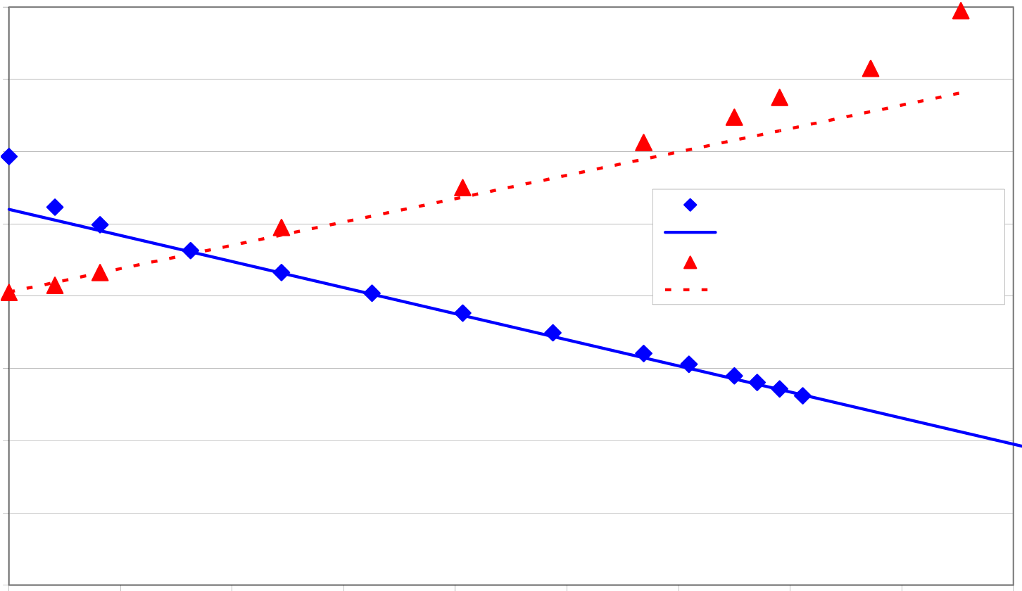

**Comparisons**

For a same temperature (900°C), the Figure 6 compares the experimental and modelling results in SOFC and HTE. A same cell points out the same features of total resistance, in SOFC as well as in HTE conditions.

**1600**

|  |  |  |
| --- | --- | --- |
| **Voltage at the boundaries of the cell (mV)** | **1400** | **SOFC 900°C** |
| **1200** |
| **1000** | **SOFC 900°C - analytical model** |
| **800** | **HTE 900°C - 10%H2** |
| **HTE 900°C - analytical model** |
| **600** |
| **400** |
| **200** |

**0**

|  |  |  |  |  |  |  |  |  |  |
| --- | --- | --- | --- | --- | --- | --- | --- | --- | --- |
| **0** | **0.05** | **0.1** | **0.15** | **0.2** | **0.25** | **0.3** | **0.35** | **0.4** | **0.45** |

**Current density (A.cm-2)**

Figure 6: Comparison of 2 experiments carried out in similar conditions (blue lozenges: SOFC; red triangles: HTE)

The Ohmic contribution is obviously symmetric. One can demonstrate that the activation contribution is symmetric too. The only discrepancy could come from the concentration contribution, which is dissymmetrical. In an improved model, these data could give an order of magnitude of the diffusion coefficients of water and hydrogen through the material of electrode.

**Hydrogen production**

HTE experiments carried out at 900°C with a gaseous mixture 90% H2O - 10% H2 lead to the production of 230.5 NmL.min-1 H2, i.e. 2.34 NmL.min-1.cm-2, at a slightly exothermic working point (1.32 V). Consumption rate was 70% water. This result is comparable to those obtained by Dornier [1] in the frame of the Project HOTELLY in the 80's. For a slightly exothermal process, the produced hydrogen flow rate was 2.56 NmL.min-1.cm-2, at 1000°C in a tubular geometry.

The decrease of H2 percentage in the inlet mixture leads to an increase of H2 production (2.47 NmL.min-1.cm-2, at 1.32 V for an initial mixture 95 / 5). This is in agreement with the operational model, and Nernst equation.

The temperature decrease leads to a very high increase of the cell resistance. As a consequence, hydrogen production sharply decreases (1.40 NmL.min-1.cm-2, at 800°C).

**Conclusions**

A simple model describing the behaviour of a solid oxide fuel cell as well as of a high-temperature electrolyser was finalised. The model is analytical (i.e. simplified), but a reasonably good agreement is found on validation against SOFC experiments, at least on the linear part of the curve voltage vs. intensity. This operational model is based on the fit of only one parameter, the global resistance of the cell. This value is the sum of three contributions:   
- an Ohmic contribution, due to the electric resistance of the current through the cell;   
- an activation contribution, due to the existence of activated complexes at the interface electrode / electrolyte, which is the site of the half-reactions of oxido-reduction;

- a "concentration" contribution, due to the difference in gas concentrations in the bulk (where they are measured, or calculated), and at the interface electrode / electrolyte, where Nernst local equation really applies.

A same resistance can characterize a cell functioning in SOFC or in HTE. However, a slight discrepancy appears in HTE processing at high intensities, thus at high voltages. It could be due to the concentration contribution to the global resistance of the cell, which is dissymmetric. More experiments are needed in order to improve this model.

**Acknowledgments**

The authors wish to thank CEA/DRT (Energy Atomic Commission, Direction of Technological Research), especially Dr. F. Le Naour and P. Baurens for their financial support and help.

Anne Laure Sauvet and Antoine Henry are acknowledged for their help in carrying out SOFC experiments.

**References**

[1]: "High temperature electrolysis of water vapour - Status of development and perspectives for application", W. Donitz and E. Erdle, Int. J. Hydrogen Energy, vol 10 n°5 pp 291-295, 1985